

**Jinnah university for women**

**Topic : rubella virus**

**Group members : beenish khan, hafiza rohma abid, lamiah Mansoor, mehak rafiq & rukhshanda ata**

**Submitted to : miss maheen**

**RUBELLA VIRUS**

**Taxonomy**

|  |  |
| --- | --- |
| [Mnemonic i](http://www.uniprot.org/help/taxonomy#organism-code) | RUBV |
| [Taxon identifier i](http://www.uniprot.org/help/taxonomy) | 11041 |
| [Scientific name i](http://www.uniprot.org/help/taxonomy#organism-denomination) | Rubella virus |
| Taxonomy | › [Rubivirus](http://www.uniprot.org/taxonomy/11040) |
| [Common name i](http://www.uniprot.org/help/taxonomy) | RUBV |
| [Synonym i](http://www.uniprot.org/help/taxonomy) | - |
| [Rank i](http://www.uniprot.org/help/taxonomy#lineage) | SPECIES |
| [Lineage i](http://www.uniprot.org/help/taxonomy#lineage) | › [Viruses](http://www.uniprot.org/taxonomy/10239)    › [ssRNA viruses](http://www.uniprot.org/taxonomy/439488)      › [ssRNA positive-strand viruses, no DNA stage](http://www.uniprot.org/taxonomy/35278)        › [Togaviridae](http://www.uniprot.org/taxonomy/11018)          › [Rubivirus](http://www.uniprot.org/taxonomy/11040) |
| [Virus hosts i](http://www.uniprot.org/help/taxonomy#host) | › [Homo sapiens (Human)](http://www.uniprot.org/taxonomy/9606) |

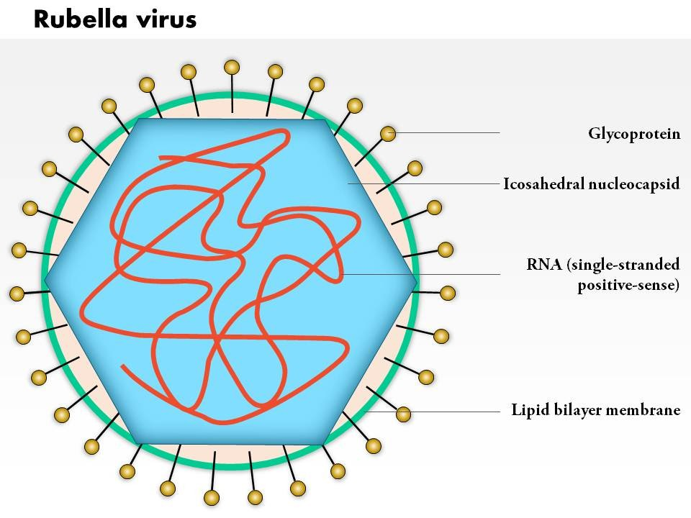

**Structure**

The Rubella virus is an **enveloped virus**, meaning it does have an envelope on the outside. Viruses of this nature are not quite as virulent as their non-enveloped brethren. The Rubella virus consists of the typical viral components, those being the genetic material in the center, followed by a capsid, , and then the envelope. Different from many other viruses is that there is no tegument between the capsid and envelope.

The genetic material (in this case RNA) is similar in scope to human DNA in that it is the blueprint for the virus which tells the virus what to do, what to look like, etc. This information is also extremely important as it instructs the virus on how and when to **replicate**or copy and then produce more viruses.

Outside of the genetic material is the **capsid**. The capsid protects only the RNA of the virus and is shaped like a 20 sided polygon, or icosahedron. The capsid of the Rubella virus has a dedicated capsid protein that is responsible for a number of functions. Its main function is to help the virus and the RNA replicate properly. It also allows for proper virus assembly.

Finally we seethe envelop of the virus. There are two jobs of envelop: to protect the entire virus and to attach to a host cell. Among the cell of envelop there are small protein projection that act as anchor. They will attach to host cell allowing the virus to infect the cell.

**Life cycle**

Entry into the host cell is achieved by attachment of the viral E glycoprotein to host receptors, which mediates clathrin-mediated endocytosis. The [receptors](https://en.wikipedia.org/wiki/Receptor_(biochemistry)) for binding are unknown, however the [tropism](https://en.wikipedia.org/wiki/Tropism) is varied and it is known that the [glycoprotein](https://en.wikipedia.org/wiki/Glycoprotein) petal-like spikes act as attachment proteins. After virus attachment and entry into the cell, gene expression and replication takes place within the [cytoplasm](https://en.wikipedia.org/wiki/Cytoplasm).

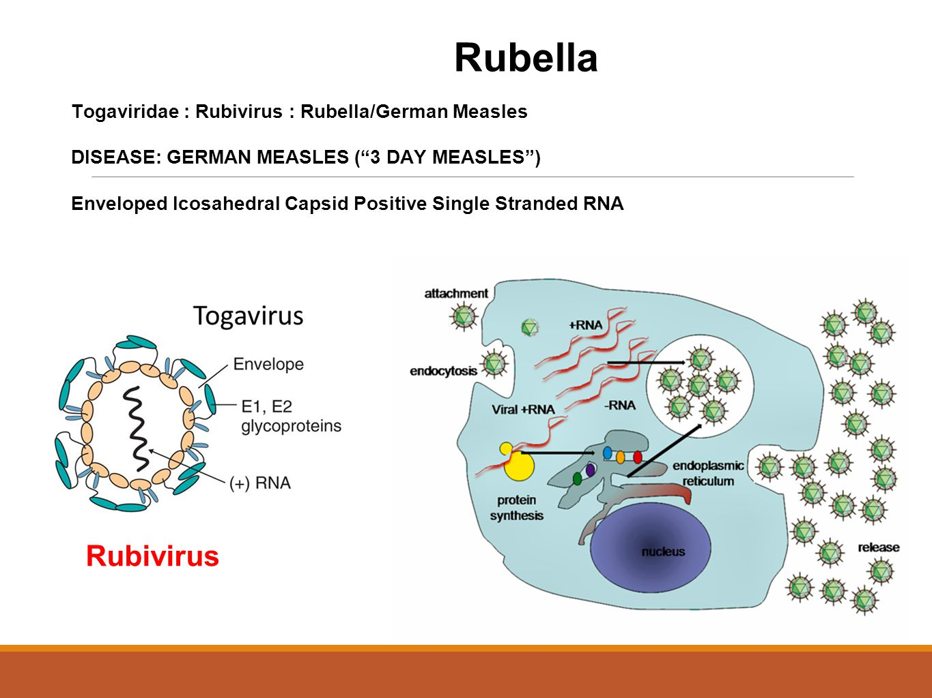

Replication follows the positive stranded RNA virus replication model. Positive-stranded RNA-virus-transcription is the method of transcription. Translation takes place by viral initiation, and suppression of termination. The [vector](https://en.wikipedia.org/wiki/Vector_(epidemiology)) for Togaviridae is primarily the [mosquito](https://en.wikipedia.org/wiki/Mosquito), where replication of the virus occurs. The Togaviridae family is classified into Old World and New World viruses based on geographical distribution, although it’s likely that a few transoceanic crossings have occurred. Human, mammals, marsupials, birds, and mosquitoes serve as the natural host. Transmission routes are zoonosis, bite, and respiratory.

|  |  |  |  |  |  |  |  |
| --- | --- | --- | --- | --- | --- | --- | --- |
| **Genus** | **Host details** | **Tissue tropism** | **Entry details** | **Release details** | **Replication site** | **Assembly site** | **Transmission** |
| Rubivirus | Humans | None | Clathrin-mediated endocytosis | Secretion | Cytoplasm | Cytoplasm | Aerosol |

**Replication:**

RV is characterized by slow replication, which is reflected in the long viral latent period of 8 to 12 h ([18](https://www.ncbi.nlm.nih.gov/pmc/articles/PMC88950/#B18), [34](https://www.ncbi.nlm.nih.gov/pmc/articles/PMC88950/#B34)). During RV infection, four distinct viral RNA species can be detected. A single-stranded 40S RV genomic RNA (3.8 × 103 kDa) and a 24S subgenomic RNA (1.2 × 103 kDa) that corresponds to the 3′ one-third of the genomic RNA are present in infected cells ([68](https://www.ncbi.nlm.nih.gov/pmc/articles/PMC88950/#B68), [109](https://www.ncbi.nlm.nih.gov/pmc/articles/PMC88950/#B109), [134](https://www.ncbi.nlm.nih.gov/pmc/articles/PMC88950/#B134)). Both contain a methyl7guanosine cap at the 5′ terminus and a polyadenylate tail at the 3′ terminus. In addition, viral replicative intermediates (RI) of 21S, representing partial double-stranded RNA (dsRNA), and viral replicative forms (RF) of 19 to 20S, representing full dsRNA, have been detected in RV-infected cells ([134](https://www.ncbi.nlm.nih.gov/pmc/articles/PMC88950/#B134), [162](https://www.ncbi.nlm.nih.gov/pmc/articles/PMC88950/#B162)).

During viral replication, the 40S RV genomic RNA serves as a messenger for the nonstructural (ns) proteins and as a template for the synthesis of a 40S negative-polarity RNA strand. The minus strand in turns acts as a template for the transcription of both the 40S RNA and the 24S RNA ([34](https://www.ncbi.nlm.nih.gov/pmc/articles/PMC88950/#B34)). Nascent 40S RNA is packaged with the RV capsid protein to form nucleocapsids. In terms of viral kinetics, both the RV 40S RNA and 24S RNA were detected at the end of the viral latent period, with viral structural proteins appearing 4 h later ([52](https://www.ncbi.nlm.nih.gov/pmc/articles/PMC88950/#B52)). Peak virus production occurs during the period from 36 to 48 h postinfection (p.i.).

One-step multiplication studies have shown that RV is unable to infect every cell at any specific time, irrespective of the titer of the input virus ([20](https://www.ncbi.nlm.nih.gov/pmc/articles/PMC88950/#B20), [52](https://www.ncbi.nlm.nih.gov/pmc/articles/PMC88950/#B52), [134](https://www.ncbi.nlm.nih.gov/pmc/articles/PMC88950/#B134), [162](https://www.ncbi.nlm.nih.gov/pmc/articles/PMC88950/#B162)). Moreover, the proportion of cells infected by RV at any one time is cell type dependent ([52](https://www.ncbi.nlm.nih.gov/pmc/articles/PMC88950/#B52), [134](https://www.ncbi.nlm.nih.gov/pmc/articles/PMC88950/#B134), [162](https://www.ncbi.nlm.nih.gov/pmc/articles/PMC88950/#B162)). However, as infection proceeds, the entire culture eventually becomes infected.

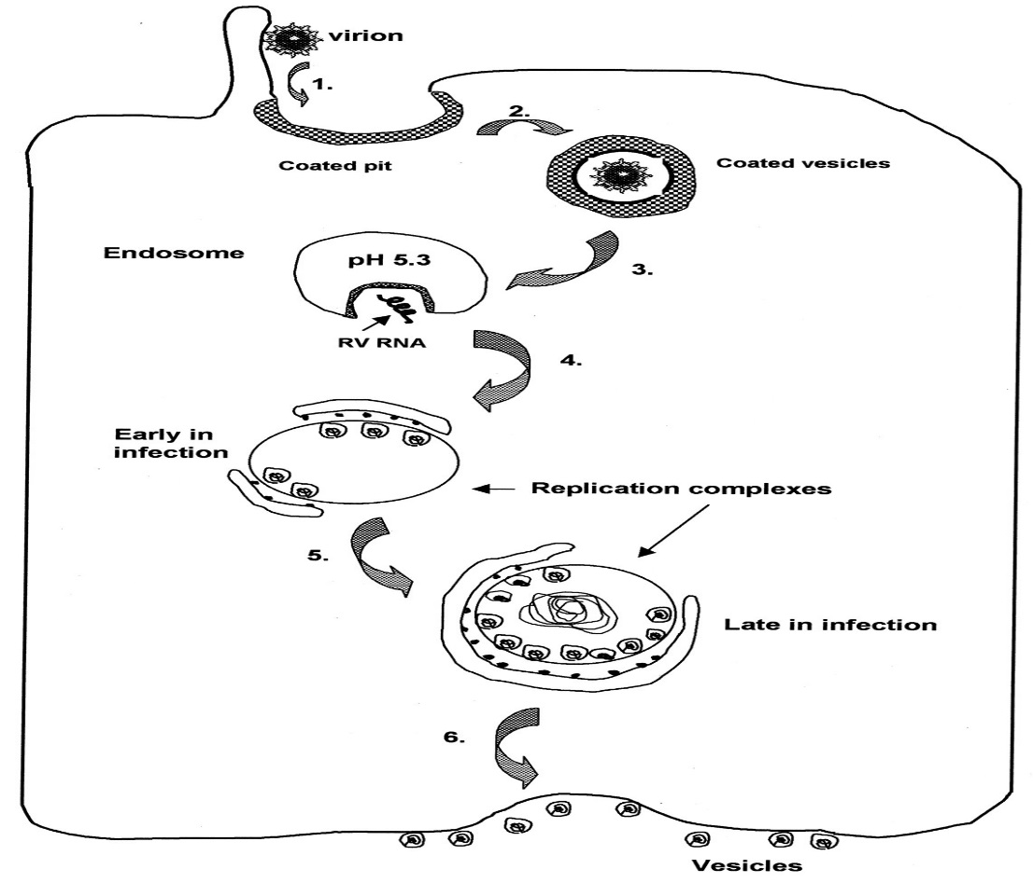

**INTRODUCTION**

**What is Rubella?**

Rubella, also known as German measles, is an acute viral infection that usually affects children and young adults. It is a contagious condition that can be transmitted between humans via airborne droplets when infected individuals cough or sneeze.

It is usually mild in children but can have severe consequences in some population groups, such as pregnant women. It has the potential to cause fetal death or birth defects to the infant. On a global basis, more than 100,000 babies are born with congenital rubella syndrome each year.

The infection is usually self-limiting and there is no specific treatment. The disease can be prevented, however, by vaccination.

**History:**

Friedrich Hoffmann, a German physician, first described a case of rubella in 1740. George de Maton suggested it was distinct from other diseases such as the measles and scarlet fever in 1814. As each of the initial recorded cases occurred in Germany, the disease became known as “German measles.” The name rubella originates from the Latin word that means “little red,” which was first used in 1866.

Throughout the 20th century, medical research discovered that rubella was caused by a virus and could be passed on via airborne droplets. Research about congenital rubella syndrome began extensively following several cases arising from an epidemic infection in Australia in 1940.

In 1962, the virus was isolated in a tissue culture, allowing the initial research for a vaccine to begin. A live attenuated virus vaccine was licensed in 1969 and introduced in combinations with other vaccines shortly after. The introduction of vaccination has greatly reduced the incidence of the viral infection and it is considered rare among developed nations today.

**Congenital Rubella Syndrome:**

Very rarely, a pregnant woman can catch rubella and pass it to her unborn baby. A baby born with the complications of rubella infection is said to have congenital rubella syndrome (CRS).

If rubella is caught within the first three months of the pregnancy, the mother may lose the baby (death in the uterus, spontaneous abortion) it can cause damage in 90% of unborn babies, including:

* eye problems, such as [cataracts](http://www.hse.ie/eng/health/az/C/Cataracts,-childhood/) (cloudy patches on the lens of the eye)
* deafness
* heart abnormalities
* brain damage

Rubella infection in the last 20 weeks of pregnancy is less serious for the mother and baby but may still lead to premature delivery and other disease complications for the baby.

Today, less than 10 [people in the United States are reported as having rubella each year](https://www.cdc.gov/mmwr/preview/mmwrhtml/rr6204a1.htm). Since 2012, all rubella cases had evidence that they were infected when they were living or traveling outside the United States. To maintain rubella elimination, it is important that children and women of childbearing age are vaccinated against rubella.

**SIGNS AND SYMPTOMS**

After being infected, the incubation period (the time it takes for the rubella virus to become established and for symptoms to appear) is 14-21 days.

Some people have prodromal (early) symptoms during the incubation period, before any other symptoms develop.

Between 25-50% of people with rubella (German measles) may not have any symptoms. If you are infected with the rubella virus but have no symptoms, it is known as a 'sub-clinical infection'.

In children, rubella is usually mild, with few noticeable symptoms. For children who do have symptoms, a red rash is typically the first sign. The rash generally first appears on the face and then spreads to the rest of the body, and lasts about three days. Other symptoms that may occur 1 to 5 days before the rash appears include:

* a low-grade fever
* headache
* mild pink eye (redness or swelling of the white of the eye)
* general discomfort
* swollen and enlarged lymph nodes
* cough
* runny nose

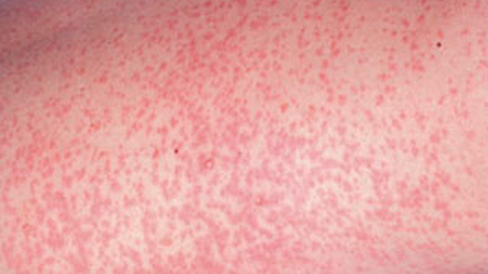

**Prodromal Symptoms:**

Prodromal symptoms can last for about five days before the rash (see below) starts to appear. These symptoms are more common in adults than children. They can include:

* a slightly raised temperature - a normal temperature is between 36-36.8ºC (96.8-98.24ºF)
* [conjunctivitis](http://www.hse.ie/eng/health/az/C/Conjunctivitis,-infective/) - inflammation of the transparent membrane that covers the whites of your eyes
* sore throat
* runny nose
* headache
* feeling unwell

**Main Symptoms:**

Some of the main symptoms of rubella are described below.

**Swollen lymph nodes**

Swollen lymph nodes (glands) usually appear behind the ears, below your skull at the back of your head, and in your neck. They can be painful. Sometimes they appear before the rash, and can last for a week after the rash has disappeared. The medical term for this symptom is lymphadenopathy.

**A distinctive red-pink rash**

The rubella rash is a distinctive red-pink colour. It appears 3-4 days after the first symptoms. The rash usually appears as spots, which may be slightly itchy. It usually starts behind the ears, before spreading around the head and neck. It may then spread to the trunk (abdomen and chest), legs and arms. The rash usually lasts for 3-7 days.

**A high temperature**

A high temperature (fever) of 38ºC (100.4ºF) or more is a symptom of rubella which, although more common in children, can be more severe in adults. Your temperature may remain high for several days before retuning to normal.

**Cold-like symptoms**

Cold-like symptoms, such as a runny nose, watery eyes, sore throat and cough, are common symptoms of rubella, particularly in adults.

**Painful or swollen joints**

Painful or swollen joints affect up to 60% of adult women with rubella, but are less common in children. Swelling tends to affect the hands, knees, wrists and ankles, but it is usually mild. It appears during or up to a week after the rash, and can last up to a month.

Other common symptoms of rubella are tiredness, irritability and a general lack of energy, plus aches and pains, and a poor appetite.

If you have rubella, you are infectious for one week before symptoms appear, and for four days after the rash has started. Children with rubella should be kept away from school. They should not mix with other children during the time they are infectious. If it is suspected that a child or an adult has rubella, they should avoid all contact with pregnant women.

**Congenital Rubella Syndrome:**

Congenital rubella syndrome (CRS) can cause the following problems in unborn babies:

* [cataracts](http://www.hse.ie/eng/health/az/C/Cataracts,-childhood/) (cloudy patches in the lens of the eye) and other eye defects
* deafness
* cardiac (heart) abnormalities
* a small head compared to the rest of the body, as the brain is not fully developed
* a slower than normal growth rate
* inflamed (swollen) wounds in the brain, liver, lungs or bone marrow

Children born with CRS can develop symptoms later in their lives as well. These include:

* pneumonitis - inflammation (swelling) of the lungs caused by a virus
* [diabetes mellitus](http://www.hse.ie/eng/health/az/D/Diabetes/) - a long-term condition that is caused by too much glucose in the blood
* thyroid gland problems - the thyroid gland produces hormones to control the body's growth and metabolism; it could be [overactive](http://www.hse.ie/eng/health/az/T/Thyroid,-overactive/) or [underactive](http://www.hse.ie/eng/health/az/T/Thyroid,-underactive/)
* progressive panencephalitis (inflammation of the brain) - this causes a loss of mental and motor (movement) functions

**CAUSES AND DIAGNOSIS**

Rubella (German measles) is a highly infectious virus that is about as infectious as flu. If you have rubella, you are infectious for one week before symptoms appear, and for four days after the rash has started.

Rubella is spread through droplets of moisture from the nose or throat of someone who is infected. These droplets are released into the air when someone:

* coughs
* sneezes
* talks

If you inhale an infected droplet of moisture, you can become infected. This can easily happen through face-to-face contact with someone who is infected, or from just being together in the same room.

**Congenital rubella syndrome:**

If a pregnant woman catches the rubella virus, it can infect her unborn baby, causing congenital rubella syndrome (CRS).

The rubella virus is spread through the pregnant woman's blood to the placenta. The virus can then spread through the circulatory system (the blood vessels and the heart) of the foetus, where it can start to cause damage.

The risk of the foetus having CRS depends on when the pregnant woman caught the infection. If the pregnant woman catches rubella:

* **during the first trimester** (up to week 13 of the pregnancy), there is an 80% chance that the foetus will also be infected
* **during the second trimester** (weeks 14-26 of the pregnancy), there is a 25% chance that the foetus will be infected
* **during the third trimester** (week 27 of the pregnancy until the birth), there is a 35% chance that the foetus will be infected during weeks 27-30 of the pregnancy; this rises to nearly 100% by week 36 of the pregnancy.

The likelihood that CRS will cause birth defects in the foetus also depends on when the pregnant woman became infected. If the pregnant woman catches rubella:

* **during weeks 8-10 of the pregnancy,** there is a 90% chance that the foetus will have birth defects
* **during weeks 11-16 of the pregnancy,**there is a 10-20% chance that the foetus will have birth defects
* **during weeks 16-20 of the pregnancy,** birth defects are rare, with only deafness being reported
* **beyond week 20 of the pregnancy,** there is little, if any, risk of birth defects developing.

**Foetus**

A foetus is an unborn baby, from the eighth week of pregnancy until birth.

**Placenta**

The organ that links a pregnant woman's blood supply to her unborn baby's.

**Diagnosis:**

**If you suspect that you or your child has rubella, phone your GP surgery straight away for advice.**

Do not visit your GP surgery without calling them first. If you do, you will put any pregnant women who may be there at risk of catching the rubella infection.

By law, doctors have to notify the Department of Public Health of all suspected cases of rubella. If necessary, they may also notify the child's school or nursery.

Your GP may suspect that you have rubella from your symptoms - for example, if you have the distinctive red-pink rash. However, a similar rash may be caused by another viral infection. A blood test is the only way to confirm a diagnosis.

Blood Test:

A sample of blood will be taken from a vein in your arm and tested for certain antibodies. Antibodies are proteins that your body produces to neutralise or destroy disease-carrying organisms and toxins. If you have rubella or you have had it in the past, your blood will test positive for certain antibodies, which are listed below.

* **The IgM antibody will be present** if you have a new rubella infection.
* **The IgG antibody will be present** if you have had the rubella infection in the past, or you have been immunised against it.
* **If neither antibody is present,** you do not have rubella and you have not been immunised against it.

Diagnosis In Pregnant Women:

If you are pregnant and have some of the symptoms of rubella, your GP may want to test you for the infection. Even if the infection is more likely to be something else, or you have been immunised against rubella, your GP may wish to rule out rubella early on. This is because of the high risk of birth defects developing in your unborn baby.

Also see your GP if you have had face-to-face contact with someone who has rubella, or if you have spent more than 15 minutes in the same room as someone who has rubella. If you have not previously been immunised against the infection, your GP may wish to do further tests. Your GP may also contact the local HPU for advice.

**TREATMENT**

There is no specific treatment for the rubella infection. The condition is usually mild and will improve without any treatment. Symptoms usually disappear within 7-10 days.

**Phone your GP surgery for advice if you think that you or your child has rubella.**

Do not visit your GP surgery unless you are advised to do so by a healthcare professional, such as your GP. If any unusual symptoms develop, such as a dark red rash, call your GP for advice.

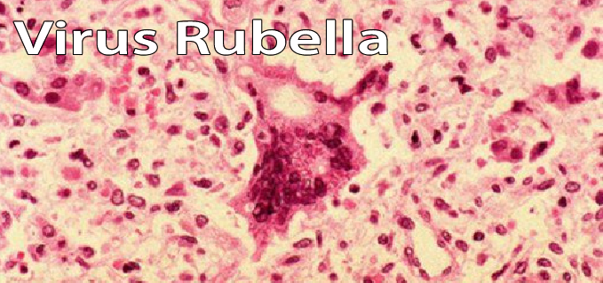

**Self-Help Treatment :**

If you have rubella, you should:

* **stay of work for five days** from the start of the rash
* **keep your child off school for five days** from the start of their rash (if they have rubella)
* **avoid any contact with pregnant women** for at least a week after the start of the rash.

The rash itself does not need any treatment. It will usually disappear within a week. The other symptoms can be treated using the advice below.  
   
**Paracetamol Or Ibuprofen**

Paracetemol or ibuprofen can be used to reduce the fever and treat any aches or pains. Liquid infant paracetamol can be used for young children. Aspirin should not be given to children under 16 years old.

**Controlling A Temperature**

A normal temperature is between 36-36.8ºC (96.8-98.24ºF). If your child has a high temperature, try to reduce it by keeping them cool. A cool (but not cold) compress, such as a damp flannel, can be used.

**Drink Plenty Of Fluids**

You need to drink around 1.2 litres (6-8 glasses) of fluid a day. If you child has a fever, make sure that they drink plenty of fluid because they may be at risk of [dehydration](http://www.hse.ie/eng/health/az/D/Dehydration/) (when the body is low in water). If you or your child has a cough, a lack of fluid will make it worse.

**Cough Medicines**

Cough medicines will be of little help if you or your child has a cough. Instead, putting a bowl of water in the room will increase the humidity and can help to relieve a cough. Alternatively, if the radiators are on, putting a wet towel on the radiator will release more water into the air.

Ensure that your child drinks plenty of fluids. Giving them warm liquids to drink may help to relax their airway, loosen mucus, and soothe a cough. However, avoid giving your child overly sweet drinks. Honey should not be given to babies under 12 months.

Antibiotics are of no use for treating the rubella virus, but they may be prescribed for any secondary bacterial infections that develop. In severe cases, involving more serious complications, hospital treatment may be required.

If you have the rubella virus, your body will make antibodies to fight the infection and get rid of it. Once you have had rubella, you are usually immune to the virus for life. It is therefore very rare to be affected by the condition more than once.

**Pregnant Women:**

If you have rubella, you should follow the self-help treatment outlined above. Check with your GP before using any medication. Ideally, you should avoid taking medicines while you are pregnant, particularly during the first three months.

If you need medication to relieve pain or reduce fever, paracetemol is preferred. Do not take ibuprofen during your third trimester (from week 27 to the birth of the baby).

**Congenital Rubella Syndrome:**

If you have confirmed rubella, and you are 20 weeks pregnant or less, you will be referred to an obstetrician (a doctor who specialises in the care of women during pregnancy, labour and after the birth). They will explain the risks of CRS to you and, if necessary, offer you counselling. You may need to have further tests, such as amniocentesis (where a sample of amniotic fluid is taken) to confirm whether your unborn baby has CRS.

There is currently no treatment for CRS. The risk of your baby being infected, and of having any birth defects, will depend on when you caught the infection (see [Rubella - causes](http://www.hse.ie/eng/health/az/G/German-measles/Causes-of-rubella.html)). Your obstetrician should be able to answer any questions that you have, and give advice about the appropriate next step.

**Amniocentesis**

[Amniocentesis](http://www.hse.ie/eng/health/az/A/Amniocentesis/) is a medical test that is carried out during pregnancy in order to assess whether the unborn baby (foetus) could develop or has developed an abnormality or serious condition.

**PREVENTION AND COMPLICATIONS**

**Preventing Rubella:**

It is possible to prevent rubella with immunisation. The [measles](http://www.hse.ie/eng/health/az/M/Measles/), [mumps](http://www.hse.ie/eng/health/az/M/Mumps/) and rubella ([MMR](http://www.hse.ie/eng/health/az/M/MMR/)) vaccination protects against rubella as well as measles and mumps.

Depending on when you were born, you may have had the MMR vaccination at some point during your school years. Alternatively, you may have had separate vaccinations for some of these infections, or had the infections themselves.

* 1. The MMR vaccine:

During pregnancy, a pregnant woman will pass protective antibodies on to her unborn baby. This means that when the baby is born, they will usually be immune to measles, mumps and rubella (German measles) for the first 12 months of their life.

The MMR vaccine is given at 12 months of age. A second dose is given to children in junior infancts in primary school except in Sligo, Leitrim and Donegal where it is given by the GP. After the first vaccine, 90-95% of children are fully immune to measles, mumps and rubella. Following the second dose, 99% are immune.

The MMR vaccine is now routinely given in more than 100 countries, including those in the European Union, North America and Australasia. Independent expert groups around the world, including the World Health Organisation (WHO) and the Department of Health (DH), agree that the MMR vaccination is preferable to having three separate injections.

It is also possible to have the MMR vaccination at any age. If you suspect that your immunisation is not up-to-date and you are at risk of catching mumps, measles or rubella, your GP may recommend that you have the MMR vaccine. For example, this may be necessary if there is an outbreak of measles, or if you are a woman who is planning a pregnancy (see below).

If you are already immunised, having the [MMR vaccine](http://www.hse.ie/eng/health/az/M/MMR/) again will not cause you any harm.

* 1. Planning a pregnancy:

If you are considering trying for a baby, and have not had two doses of MMR vaccine ask your GP to test your immunity to rubella before you become pregnant.

If the test shows that you do not have very few or no rubella antibodies, you will be offered the MMR vaccine to protect you against rubella. You can have the MMR vaccine before you become pregnant, but not during pregnancy. After having the MMR vaccine, you should take care to avoid becoming pregnant for one month.

* 1. If you are pregnant:

If you are already pregnant, you will be offered a rubella immunity test by your GP or midwife as part of your antenatal care. Most women are immune and no further action is required.

If you are not immune to rubella, try to avoid anyone who has the rubella virus. Inform your GP if you come into contact with anyone who has the rubella virus (see box, right).

You can receive the MMR vaccination after giving birth to protect you against rubella in the future. The MMR vaccine can be given to breast-feeding mothers without any risk to their baby.

**Complications:**

The risk of developing complications from the rubella virus is increased in people who have a weakened immune system - for example, as a result of conditions such as [leukaemia](http://www.hse.ie/eng/health/az/L/Leukaemia,-acute-myeloid/), or [HIV and AIDS](http://www.hse.ie/eng/health/az/H/HIV-and-AIDS/).

Most rubella-related complications, although alarming, are not usually serious.

Common complications of rubella include:

* **diarrhoea and vomiting**
* **inner ear infection (otitis media)**and inflammation
* **convulsions** - a sudden involuntary movement in a part of a body that is brought on by fever

Some other, less common, complications of rubella are described below.

* [Pneumonia](http://www.hse.ie/eng/health/az/P/Pneumonia/) - inflammation in the lungs caused by an infection. It causes fast, laboured breathing and chest pain.
* [Bronchitis](http://www.hse.ie/eng/health/az/B/Bronchitis/) - an infection of the main airways (the bronchi) in the lungs. This causes a cough, which may bring up yellowy-grey mucus.
* [Croup](http://www.hse.ie/eng/health/az/C/Croup/) - an infection that affects the voice box (larynx) and the airway to the lungs (trachea). This causes a barking cough and a rasping sound when you breathe in.
* Encephalitis - inflammation of the brain. This is a rare but serious complication, affecting one person in every 6,000 people who are infected with rubella.
* Thrombocytopaenia - an abnormal drop in the number of platelets  in your blood (platelets are cells that help your blood to clot). Thrombocytopaenia can cause bleeding into your vital areas, such as your eyes or your brain. It can affect one person in 3,000 with rubella, and is slightly more common in children.

However, if you're pregnant when you contract rubella, the consequences for your unborn child may be severe. Up to 90 percent of infants born to mothers who had rubella during the first 12 weeks of pregnancy develop congenital rubella syndrome. This syndrome can cause one or more problems, including:

* Growth retardation
* Cataracts
* Deafness
* Congenital heart defects
* Defects in other organs
* Mental retardation

The highest risk to the fetus is during the first trimester, but exposure later in pregnancy also is dangerous.

**Refrences:**

<http://www.hse.ie/eng/health/az/G/German-measles/>

<http://www.medbroadcast.com/condition/getcondition/rubella>

https://en.wikipedia.org/wiki/Togaviridae